It is well known that the food we take undergoes a series of complex reaction within the body which constitutes what we call digestion and metabolism. These reactions are catalysed by enzymes which are specific in their action and able to function properly only when the PH of the medium is within a specific range. **Some enzymes require mildly alkaline medium while others operate only in weakly acidic conditions**. Among the latter category of enzymes are the enzymes which control the digestion of proteins present in the food as it reaches the stomach. In the stomach dil. HCL is secreted & it provides mildly acidic conation required for the functioning of proteins digesting enzymes in the stomach. However sometimes the stomach begins to secrete an excess of HCL. This condition is called **gastric hyper acidity** and is because by over eating and highly spiced food. This inferes in the normal digestion and leads to acute discomfort due to indigestion. Now a days there are available many commercially products known as antacids which neutralise the excess of HCL secreted in the stomach. **The action of antacids is based on the fact that a base can neutralise acid forming salts and water**. An essential requirement of antacid is that it must not supply an excess of alkali which may lead to alkaline contions, thus making enzymes ineffective. This is achieved in the commercial antacids by incorporating other constituents which helps to keep the PH within an acidic range. These drugs counteract the acid secreted by the stomach mainly to provide symptomatic relief and a lesser extent to promote heealing. Stomach keeps on empting itself and the action of antacids lasts only for a short while, irrespective of the dose taken. It is therefore, important to take antacids at frequent intervals. Commonly used antacids are **Omez, Zintac, Ranikan, Reflux, Famtac and Aciloc**.

**AIM**

This project aims at analysing of the commercial antacids to determine how much HCL of given normality they can neutralise.

**Experiment**

To analyse the given sample of commercial antacids by determining the amount of HCL the can neutralise.

* 1 L of approximately N/10 HCl solution is prepared by by dilution of 10 mL of the concentrated acid of 1L.
* Similarly 1 L of approximately N/10 NaOH solution is made by dissolving 4.0 gram of NaCl.
* N/10 Na2CO3 solution is prepared by weighing exactly 1.125gm of anhydrous sodium carbonate and then dissolving it in water to prepare exactly 0.25 L of solution.
* The HCL solution is standardized by titrating it against the standard Na2CO3 solution using methyl-orange as indicator.
* Similarly NaOH solution is standardized by titrating against standardized HCl solution using phenolpthalein as indicator.
* The various samples of antacids tablets are powdered and Igm each is weighed.
* A specific volume of standardized HCL is added to each of the samples taken in conical flask. The acid should neutralise all the comical flask, the and should neutralize all the alkaline component of the tablet.
* 2 drops of phenolphthelein is added and the flask are warmed till most of the powder dissolves. The insoluble material is filtered off.
* The heated solutions are cooled at first for same time, so that during the time of titration the water vapours do not go out.
* This solution is titrated against the standardized NaO solution, till a permanent pink tinge is obtained. The experiment is repeated with different antacids

**Standardisation Of HCl**

|  |  |  |  |
| --- | --- | --- | --- |
| S.No. | Initial Reading | Final Reading | Volume of used Acid |
| 01 | 0 | 11.5 | 11.5 |
| 02 | 11.5 | 23 | 11.5 |
| 03 | 23 | 33 | 10 |

Concordant Reading : 11.5

Applying Normality Equation,

N1V1 = N2V2

0.1 X 20 = N2 x 11.5

Normality of NaOH = 0.174

**Analysis of Antacid Tablets**

|  |  |  |
| --- | --- | --- |
| Antacid | Volume Of NaOH used for neutralising unused HCl 1mL | Volume of HCl used for neutralising 1gm of antacid |
| Omez | 30.5 | 20 |
| Zintac | 40.0 | 20 |
| Reflux | 31.8 | 20 |
| Ranikan | 42.5 | 20 |
| Famtac | 47.5 | 20 |
| Aciloc | 49.0 | 20 |

**Weight of the antacid table powder = 1.0gm**

**Volume of HCl solution added = 40mL**

Conclusion

The antacid for which the maximum value of neutralizing is more effective.

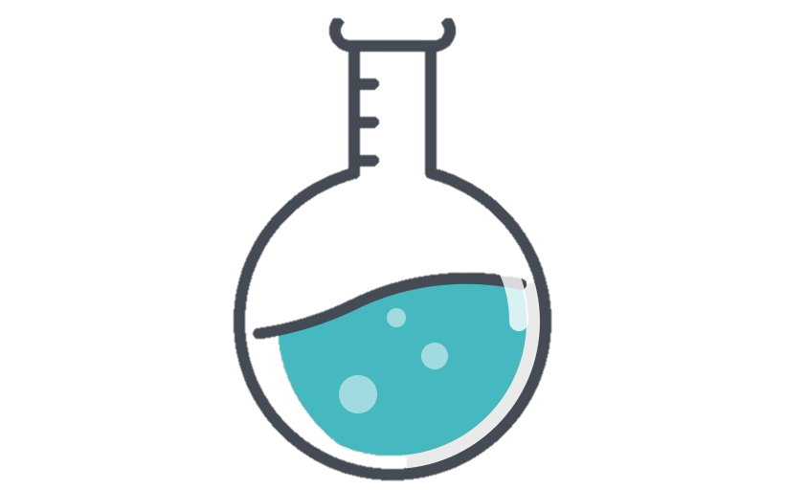

Observation in the above experiments reveal that the most effective among the common antacids that are used in this project is Omez.